Oct 20, 2022

Discussion with Operation SME’s

The goal / functionality must include the following:

* Single data entry – assignment, crew management – by Dispatcher
* Manage Crews on Single Sheet up to 3 weeks out – by Manager
* Manipulate and assign crews on a single page – by Dispatcher
* They **do not** want to assign jobs to the forecast sheet
  + Only on “Truck Board”
* This information **must** be passed to the rig board/call sheet once assigned
* If crews are correct (no manipulation required), they can be assigned on the rig board as current functionality
  + This shows on rig board and other new sheet (“Truck board”) as an assignment
* They are managing crews in a 24 hour window. Looking out 48 hours maximum.
  + Assign up to 2 jobs per crew max. Once 1 is complete they can add another second job
  + Show confirmed (assigned) and then next potential job – hours remaining dependent
* Notes are critical – mark unavailable, training, vacation start etc
* Colors are critical – how to allow color? Down trucks etc.
* Will manage up to 20 rigs in a single district – page room is critical

Manager Crew Management:

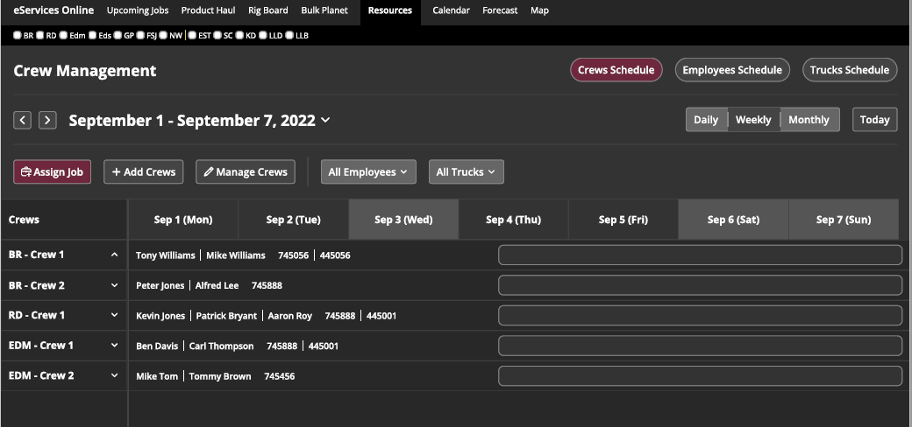

* Crews have effective date
* Crews have expiry date
  + Allow flexibility in todays and future work schedule
* Have “Home District” and “Working District”
  + To help filtering in the job assignment section

Ability to create crews up to 3-4 weeks out in the future. Starting point for the managers. In this time frame a crew count and truck count will be available. This will populate the Pumper and Bulker Utilization sheet for each timeframe. Don’t need to assign jobs from here. This is only to manage the crew assignment. These are the crews available to job assignments. Notes here carry forward and assigned to crew.

The following sheet is required for availability, with the ability to modify days/shift by employee

For crew assignments, only need to see today and tomorrow (Smaller timeframe).

May look like the following:

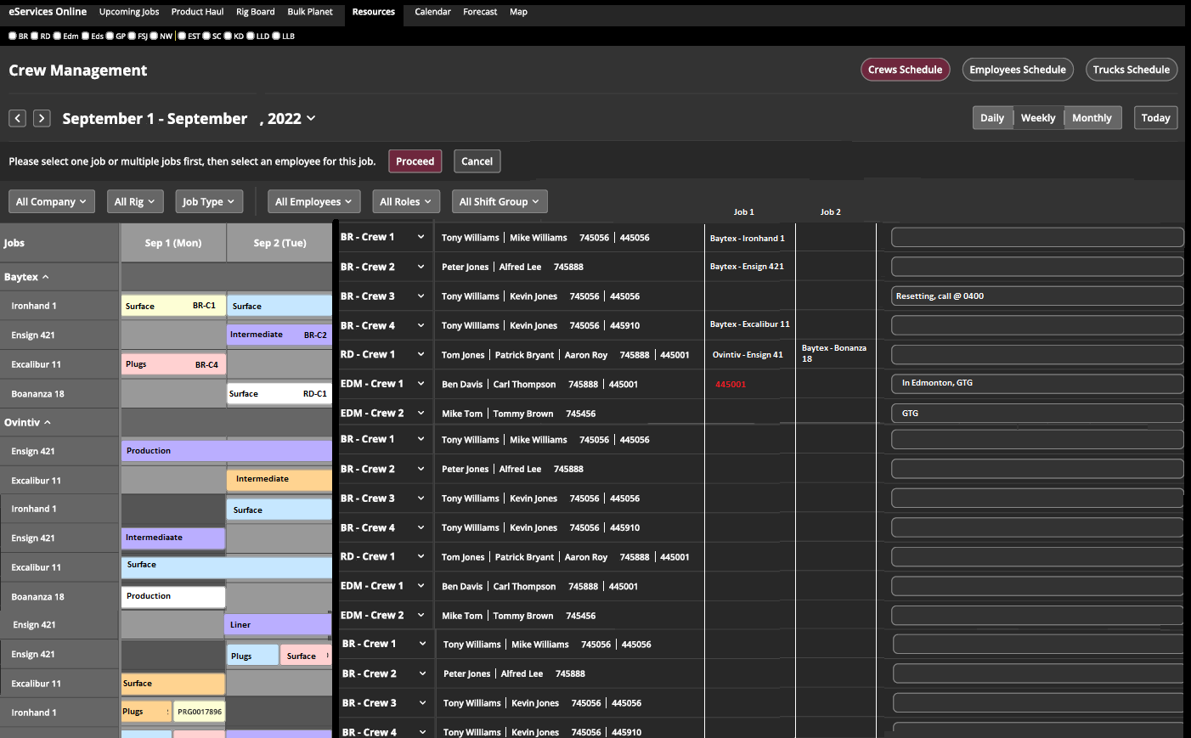

* Crew names
  + Need to define how the crews are named.
  + The crews do not always work out of their own district so named by district may not be appropriate
* Need to define operating district
  + Where is the crew operating?
  + When filtering by district, crews working in another district should appear in both home district and operating district
  + In crew schedule, we need to define operating district
* Color code the jobs to that of the rig board
  + Use the status’ and color already used on the rig board
* Ability to filter by:
  + District
  + Crew
  + Employee
* Ability to Assign crew to a job
  + Click on Job, assign crew as crew
  + Once assigned, it shows up on in Job 1 or Job 2
    - If there are no job assignments, it shows up as job 1
      * If there is already a crew assignment as job 1, job shows up as job 2
      * Job 2 is plan, but may change
      * Job 1 is removed once it is complete
        + Complete by eService status

or

* + - * + By dispatch selection (in the instance connection is lost/poor)
      * Once job 1 is complete, job 2 becomes job 1
    - Must be simple to swap crews on any job, minimize clicks
      * Drag & drop idea
        + Take “Job 1” and drag it to another crew

or

* + - * On arrow, show employee availability by position, click on “+” or “-“ to add and remove people and/or equipment
  + Once crew is assigned, it appears on:
    - rig board
    - call sheet
    - job schedule on left of above picture (BR-C1)
* Ability to manage font color
  + Use red, yellow, greed
    - Red is down, cannot do work
    - Yellow – pay attention
    - Green – confirmed work/crew
  + Or use a drop down/eservice status to indicate required color
* Ability to add notes assigned to crew
* Add Details on hover
  + Hover details are editable by dispatch
    - Truck Hover - Prorate, permits, plunger size/pressure rating
    - People Hover – Hours available, days left in rotation
* Undo
* Bulkers can be assigned as crew and on the list as well